Generative AI Use Statement

Class No.: EAP27
Name: Chopin (HE Yanning) 12311512

Part 1 Disclosure Statement: Please check all boxes that apply.

I did not use generative AI tools in creating this paper.
or
I did use generative AI tools in creating this paper, namely ___ ChatGPT______(ChatGPT, Grammarly, Google Translate, etc.). I used it in the following ways (check which of the following acceptable uses were utilized):
- Brainstorming
- Generating ideas/topics/research questions
- Outlining help
- Language/grammar/spelling/punctuation/mechanics help
- Others (Please be specific):
and
- I affirm I did not generate text with artificial intelligence and directly copy it into my paper.
- I affirm I have checked the information (e.g. evidence, examples, sources of research) provided by AI to avoid misinformation used in writing.
- I will provide a reflection on using generative AI tools in Part 2.
- I will attach screenshots of the most relevant interactions with AI in Part 3.

Part 2 Analysis and Reflection

- The reasons I use AI in writing this paper include:
I have cited too many references and need to use AI to check if their APA7 edition format is correct. And the topic about legalization of recreational cannabis use was new for me so that I need to use AI to have a comprehensive understanding of this topic. Given that the article is too long for me to check it again, with nearly a thousand words, I had to choose to use AI to help me check for any grammatical errors. Although I can come up with all relevant arguments on my own, I need the Artificial Intelligence to help me refine the logical connections between these arguments.
- I find using AI tools has the following pros and cons:

The advantage of using AI is that AI is really convenient and can provide a lot of useful information to help with my research paper writing. However, the disadvantage is that some of the information provided by Artificial Intelligence is either debunked or unverified, and I have to check these sources to make sure they really exists and could be references.

Part 3 Appendix (attach screenshots and/or line-by-line comparison below)

Please attach the most relevant interactions with AI in each category if it applies and provide explanations of how you use the information generated by AI in writing. You may write explanations in Chinese.

- Brainstorming
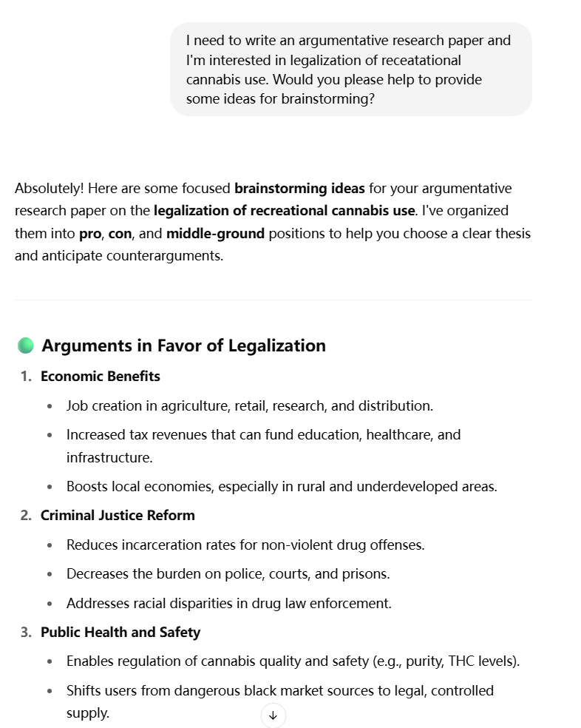
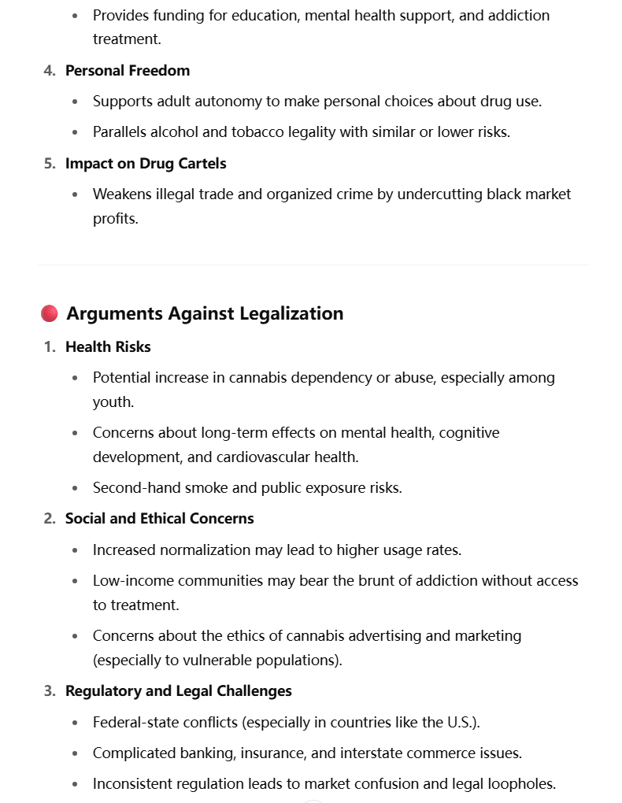
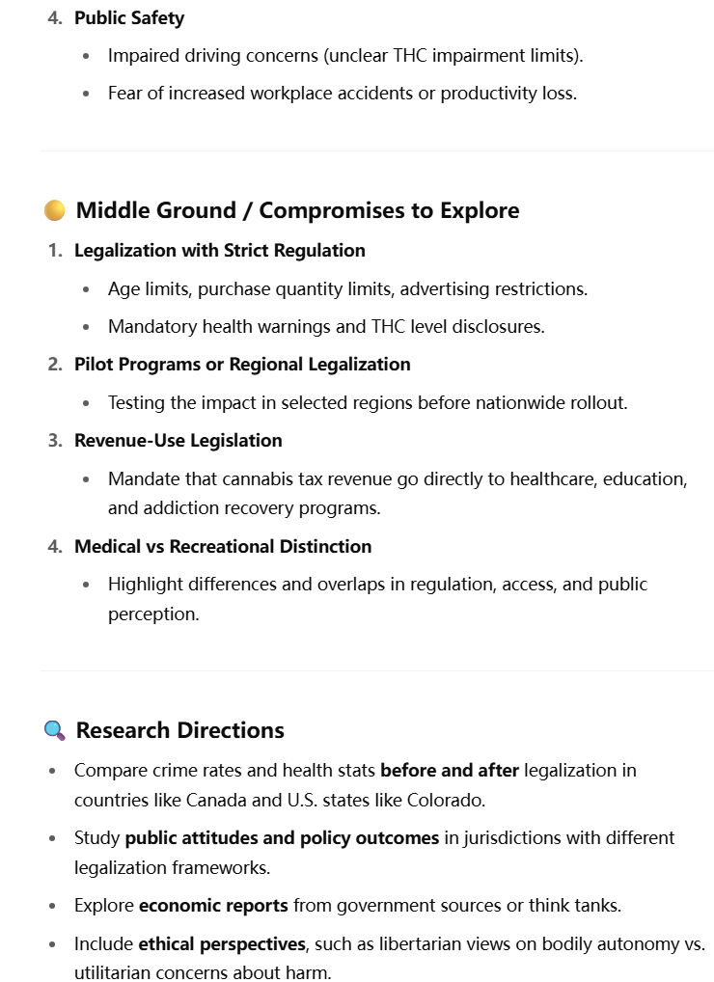
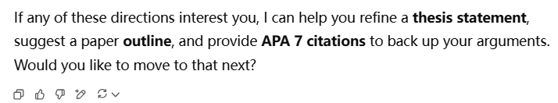
Explanation:
Our topic is about the legalization of marijuana, so I asked ChatGPT for some ideas. When I read ideas related to the economy and health, I became interested in them, started reading articles on these topics, and conducted further research on the subject.

- Generating a research question
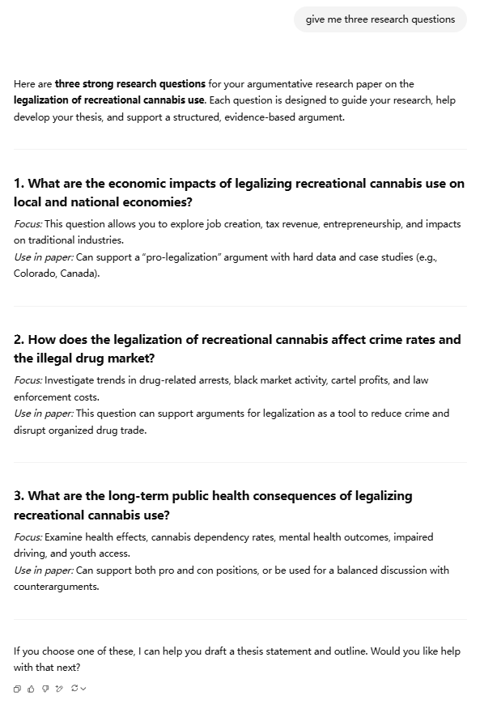

Explanation:
Ask the possible research questions about the legalization of recreational cannabis use and there it provides me three parts: economy, health and crime rate. The three parts make me interested and decide to use them in my research paper. And for economy, I explore the job creation, tax revenue and impacts on traditional industries. For health, search for the cannabis dependency rates, youth access and mental health outcomes. The last one for crime rate, I do read a lot of journals about drug-related arrests, black market activity and law enforcement costs.

- Outline help
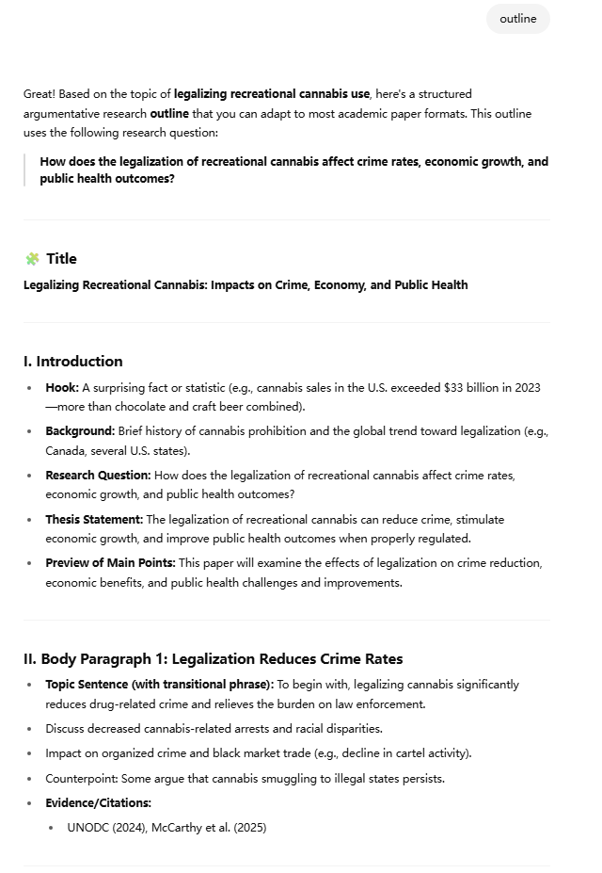
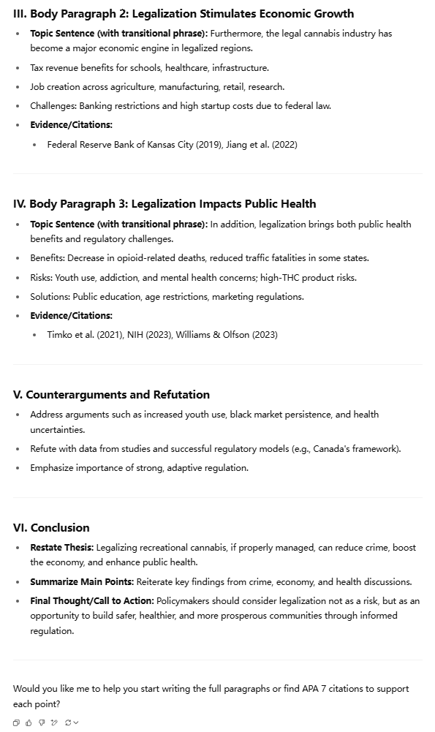

Explanation:
After reading some articles related to my research topic on the legalization of marijuana, I found a few reasons why the legalization of marijuana is gaining support. After I provided my reasons to support my idea, ChatGPT offered a very detailed outline, which was useful for structuring my writing. I found the counterarguments mentioned by ChatGPT particularly helpful for crafting the counterargument paragraph. I discovered that people are more likely to support the legalization of marijuana if they are informed about its potential economic and health benefits.

- Language/grammar/spelling/punctuation/mechanics help

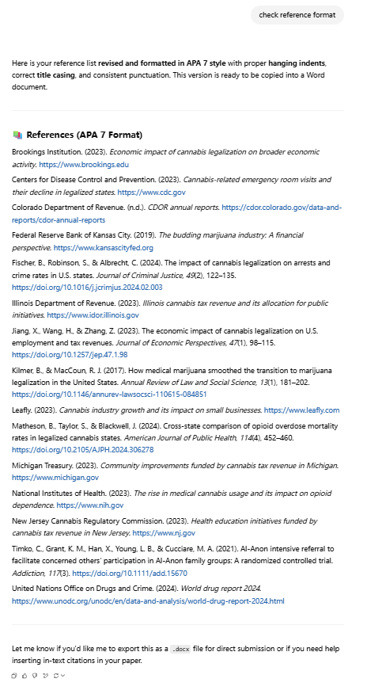

Explanation:
For references, change its format to the APA7 format. And help me to make the journals name be italic. （让journal字体变成斜体）

